Computer Programming Using Kivy 1.7.2 - Canvas 2 - Using Mouse with Canvas
GOAL: make a program that moves something to where the user clicks (or taps on mobile)

Open the canvas1 example program, and change it to also move up and down:
- File,Open, StudentSharedFiles, ComputerProgramming, Exampes, canvas1-needsUpAndDown.py
- File, Save As, click Computer, your home drive (H:) then name the file canvas2mouse.py
- To define a touch event handler and bind it to the touch event, make the changes circled in red below:
  - The size attribute of kivy Rectangle objects is a list that contains two numbers—they are the width, and height (so size[0] is width, and size[1] is height).
  - In order for clicking to move the center of the player instead of the corner, you can subtract half of the width to center it horizontally, and half of the height to center it vertically (this is done in the circled canvasTouchDown method below)
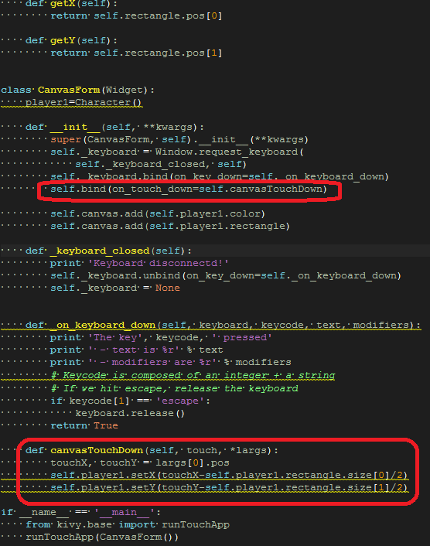
- Try running the program. The square should move to where you click the mouse.
- See what happens if you change the values so the program does not center the object on the mouse:
